🚀 POST 1 — Foundations of AI / GenAI System Design

**#AI** **#System** **#Design**

Why AI systems need a new architecture mindset

Over the last year, we’ve all seen a shift: traditional software design patterns are no longer enough for modern AI applications.

AI systems don’t behave like deterministic microservices — they reason, retrieve, interact, and evolve.

That means our architecture thinking must evolve too.

Here’s the foundation for everything that will come in this series 👇

🔵 1. AI systems are not request–response… they are reasoning systems

Traditional systems are predictable.

AI systems are probabilistic and context-driven.

Your design must account for:

a) Variable outputs

b) Tool-use decisions

c) Knowledge gaps

d) Context windows

e) Latency across multiple components

This alone changes how we design flows.

🔵 2. The Core Building Blocks of Modern AI Architecture

Every meaningful GenAI system today includes some combination of:

✔ LLMs — local, cloud, NIM, on-prem

✔ Agents — planners + executors + tool routers

✔ Tools/APIs — internal, external, MCP-based

✔ RAG Pipelines — retrieval, ranking, grounding

✔ Memories — short-term, long-term, vector DB

✔ Storage — relational, NoSQL, object stores

✔ Guardrails — validation, constraints, policies

AI is no longer “just call a model.”

It’s a composition of reasoning and operational layers.

🔵 3. What Makes AI System Design Unique?

A few principles that separate it from classical design:

a) Determinism → Probabilistic reasoning

b) Workflows → Dynamic decision graphs

c) Single service → Multi-component orchestration

d) Synchronous → Mixed async + streaming

e) Static rules → Learned behavior + guardrails

Designing AI isn’t about plugging in GPT or Llama —

it’s about shaping a reasoning architecture that behaves reliably.

🔵 4. The AI Architecture Lifecycle (New Mental Model)

Every AI system goes through five layers of reasoning:

1️⃣ Sense — accept user input (text, files, APIs)

2️⃣ Understand — embed, parse, classify, frame the task

3️⃣ Retrieve — relevant knowledge, documents, policies

4️⃣ Reason — plan, decide, generate, evaluate

5️⃣ Act — call tools, update memory, respond

This cycle will guide the structure of every post in this series.

🔵 5. The Road Ahead — What This Series Will Cover

Over the next posts, I’ll break down:

1) Single-agent design principles

2) Multi-agent orchestration

3) Memory & context-window management

4) Scaling & deployment patterns

5) Local vs cloud vs NIM vs VPC LLM choices

6) Rate limits, retries, timeouts, circuit breakers

7) Security constraints in AI, RAG & MCP

8) Choosing the right LLM for your use case

9) Quantization, caching, embeddings, vector stores

10) TOONs, sandboxes, MCP codegen, and more

If you build AI applications — or plan to — this series will give a deep, practical blueprint.

🔽 Up Next: Post 2 — Single Agent Architecture: Core Design Principles

Just stay tuned.

**#AI** **#GenAI** **#SystemDesign** **#Agents** **#RAG** **#MCP** **#LLMArchitecture**

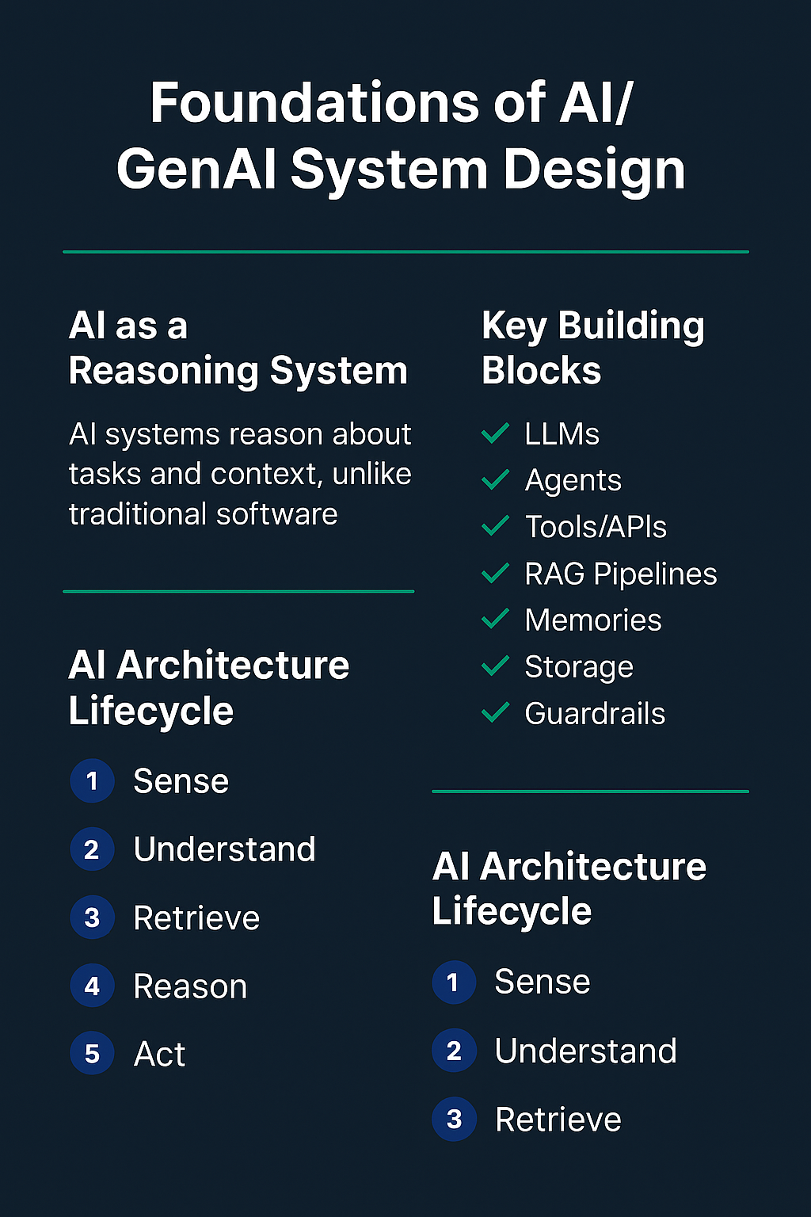

🚀 POST 2 — Single Agent Architecture: Core Design Principles

Everyone talks about “agents,” but very few understand how a single agent is actually designed.

A well-architected agent is predictable, reliable, and reusable — not just “an LLM calling tools.”

Here are the core principles 👇

🔵 1. A Single Agent = Planner + Executor + Memory + Tools

A good agent is structured, not magical.

a) Planner → decides what to do

b) Executor → performs tasks / calls tools

c) Memory → retains short-term or task facts

d) Tools → APIs, RAG, MCP, DB queries

🔵 2. Scope Should Be Narrow

A single agent should do one job extremely well.

Focused scope = predictable behavior.

Wide scope = drift + hallucinations.

🔵 3. LLM Is the Brain — Not the System

LLM handles reasoning.

Everything else (retrieval, API calls, rules) must be externalized for reliability.

🔵 4. Tools Are the Agent’s Real Capability

Agents gain power when they can:

✔ Call APIs

✔ Trigger workflows

✔ Use RAG

✔ Access MCP resources

✔ Run code safely

Tools = capability.

LLM = intelligence.

Agent = orchestrator.

🔵 5. Guardrails Are Part of Architecture

Every production agent needs:

a) Schema enforcement

b) Validation

c) Timeouts & retries

d) Tool restrictions

e) Safe execution paths

Guardrails turn an LLM-based flow into a system, not a demo.

🔵 6. Memory Must Be Minimal & Structured

a) Short-term → session context

b) Task memory → extracted facts

c) Long-term → only when needed

Too much memory = noise

Too little = repetition

Balance > quantity.

🔵 7. Master a Single Agent Before Multi-Agent

If one agent is unstable, multiple agents multiply the chaos.

Foundation first → then orchestration.

🔽 Up Next: Post 3 — What Goes Inside a Single Agent?

Just stay tuned.

**#AI** **#GenAI** **#Agents** **#SystemDesign** **#LLM** **#RAG** **#MCP**

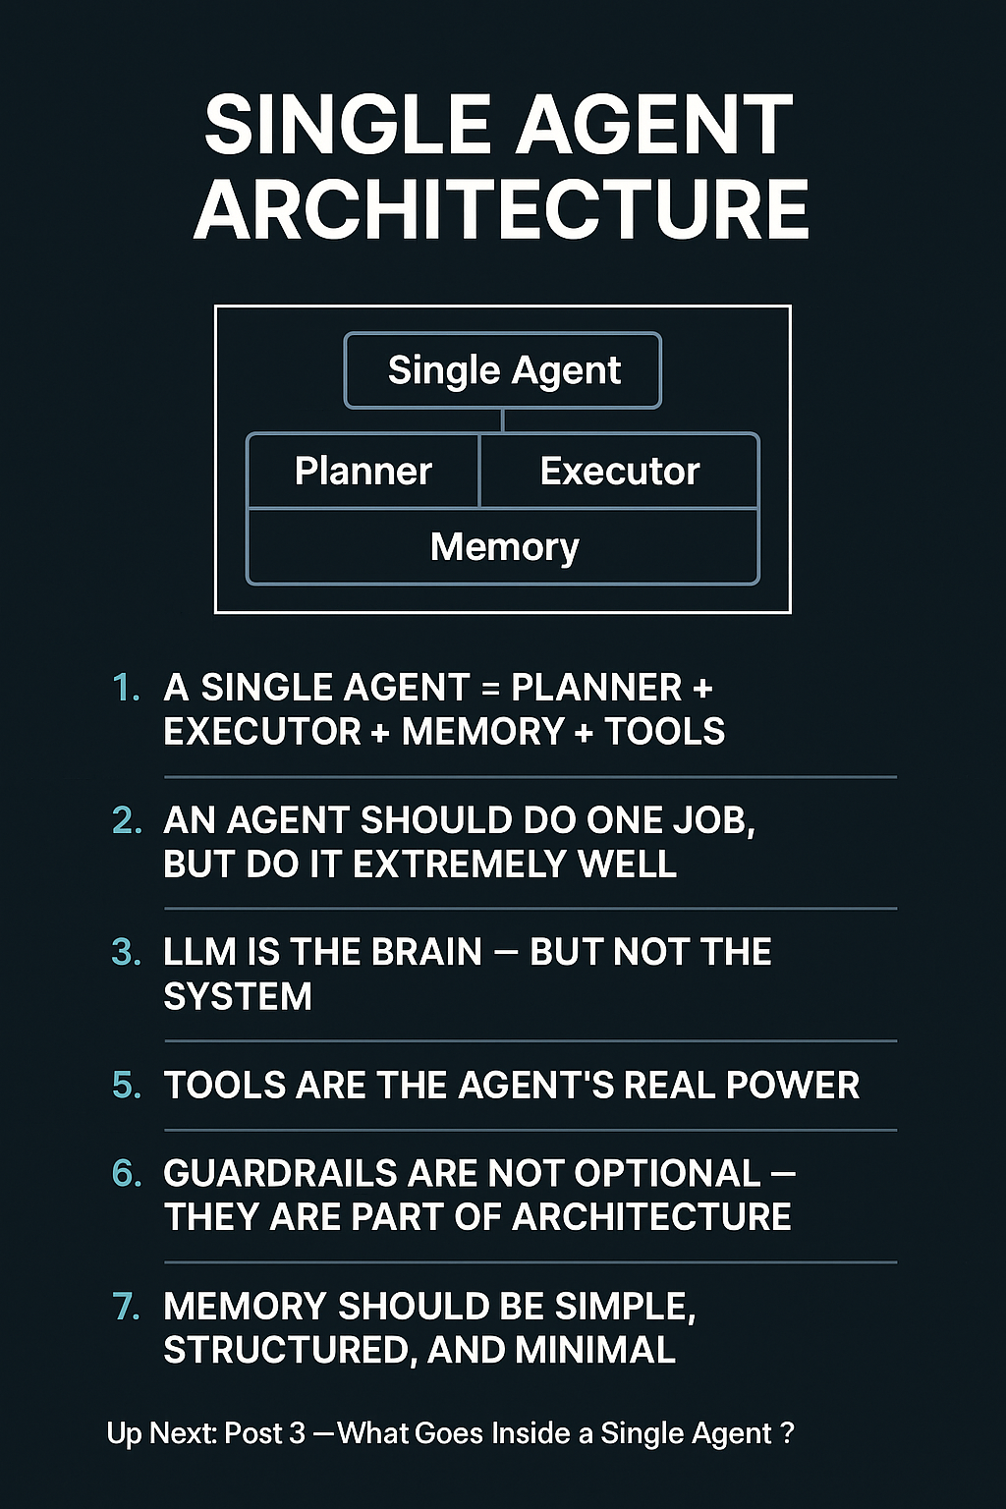

🚀 POST 3 — What Goes Inside a Single Agent? (Internal Architecture Deep Dive)

**#AI** **#GenAI** **#Agents** **#SystemDesign**

In Post 2, we covered how a single agent should behave.

Today we go deeper: what actually lives inside a well-designed agent?

Most people think an agent is “just an LLM calling tools.”

In reality, a production-grade agent is a collection of internal components working in harmony.

Here’s the clean breakdown 👇

🔵 1️⃣ APIs & System Integrations

A real agent must interact with enterprise systems.

Typical integrations include:

a) SOAP / REST / GraphQL services

b) Internal microservices

c) DB queries (SQL/NoSQL)

d) External SaaS APIs

These integrations become the action surface of the agent.

🔵 2️⃣ MCP Tools, Resources & Prompts

Modern agents use MCP as a structured capability layer:

a) Tools → actions (ex: call service, read file, fetch data)

b) Resources → documents, PDFs, tables, configs

c) Prompts → reusable reasoning patterns

MCP gives an agent a clean contract to interact with systems.

🔵 3️⃣ RAG Modules (Retrieval, Ranking, Grounding)

Inside an agent, RAG acts as the knowledge engine:

a) Retrieves relevant documents

b) Ranks & filters noise

c) Grounds the LLM on facts

d) Reduces hallucinations

A good agent doesn’t “guess” — it retrieves + reasons.

🔵 4️⃣ Execution Layer (Local + Remote)

Actions can run:

1) Locally (Python/Node handlers, sandbox code)

2) Remotely (API calls, server functions, cloud tools)

This layer manages:

a) Timeouts

b) Retries

c) Error handling

d) Structured outputs

This is where reliability lives.

🔵 5️⃣ Memory Layers (Session, Task, User)

A powerful agent uses minimal but structured memory:

a) Session context → recent conversation state

b) Task memory → extracted facts, running metadata

c) User context → optional long-term preferences

Good design = store only what helps reasoning.

🔵 6️⃣ Decision Logic: LLM vs Rules vs Hybrid

Inside every agent is a decision engine:

✔ LLM-based planning → flexible reasoning

✔ Rules/constraints → enforce hard boundaries

✔ Hybrid logic → best for enterprise workflows

The agent shouldn’t rely blindly on the LLM —

it should reason within constraints.

🔵 7️⃣ The Internal Loop: Plan → Act → Observe → Update

A well-designed agent repeats this cycle:

1️⃣ Plan (LLM)

2️⃣ Act (tool/API/RAG)

3️⃣ Observe results

4️⃣ Update memory

5️⃣ Continue until completion

This loop turns an agent into a self-contained reasoning system.

🔽 Up Next: Post 4 — Multi-Agent System Design (Orchestration vs Collaboration)

Just stay tuned.

**#AI** **#GenAI** **#Agents** **#MCP** **#RAG** **#LLM** **#SystemDesign**

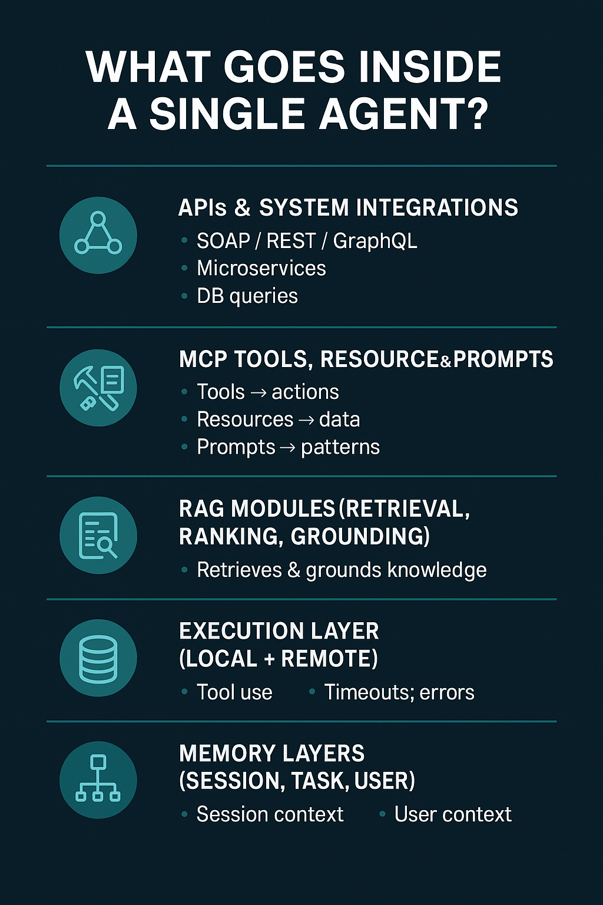

🚀 POST 4 — Multi-Agent System Design (MAS)

**#AI** **#GenAI** **#MultiAgent** **#SystemDesign** **#Agents**

As AI systems get more complex, a single agent is not enough.

Multi-Agent Systems (MAS) allow multiple specialized agents to reason, plan, and execute together.

Here’s the blueprint 👇

🔵 1️⃣ Orchestration vs Collaboration

Orchestration (Central Brain):

a) One manager agent controls others

b) Predictable, debuggable

c) Best for enterprise workflows

Collaboration (Peer-to-Peer):

a) Agents communicate directly

b) Distributed knowledge

c) More flexible, less predictable

Orchestration = order

Collaboration = autonomy

🔵 2️⃣ How Agents Understand Each Other’s Capabilities

Agents share capability signals through:

a) Capability metadata (skills/tools)

b) Tooling graphs (function map)

c) Structured APIs / MCP tools

d) Self-descriptions

LLM-based reasoning selects the next agent using these signals.

Note:

These capability signals are typically exposed via Agent Cards — structured manifests describing each agent’s skills, tools, and domain expertise. Orchestration layers use these cards to select the right agent for the next step.

🔵 3️⃣ Routing Strategies in MAS

✔ Capability Graph Routing — choose agent by predefined skills

✔ Metadata Routing — domain, tools, cost, latency

✔ LLM Arbitration — LLM chooses next agent (with guardrails)

✔ Hybrid Routing — rules + LLM (best practice)

🔵 4️⃣ When to Use MAS (vs RAG-only vs Single-Agent)

Use MAS when:

✔ Multiple skills required

✔ Distinct roles (planner, researcher, evaluator)

✔ Need scalable, modular reasoning

✔ Domain-specialized agents add value

Use RAG-only when:

✔ The task is “retrieve the right knowledge”

✔ No multi-step reasoning

Use a Single Agent w/ Tools when:

✔ API calls or simple workflows

✔ Low-latency tasks

🔵 5️⃣ Communication Patterns

a) Sequential → agent → agent → agent

b) Parallel → agents work concurrently; merge outputs

c) Event-driven → agents activate when triggered

Parallel/event models scale better but require stronger coordination.

🔵 6️⃣ Failure & Recovery Patterns

MAS must handle:

a) Agent misunderstanding

b) Conflicting decisions

c) Loops / deadlocks

d) Tool failures

Recovery uses:

✔ Fallback agents

✔ Timeouts + arbitration

✔ Loop fencing

✔ Retry / state rewind

🔵 7️⃣ When NOT to Use Multi-Agent Systems

❌ Tools alone solve the task

❌ Latency becomes worse with multiple agents

❌ Workflow is simple

❌ Agents duplicate capabilities

Simplicity > unnecessary complexity.

🔽 Up Next: Post 5 — Memory & Context Window Management Techniques

Stay tuned.

**#AI** **#GenAI** **#MultiAgent** **#LLM** **#SystemDesign** **#Agents**

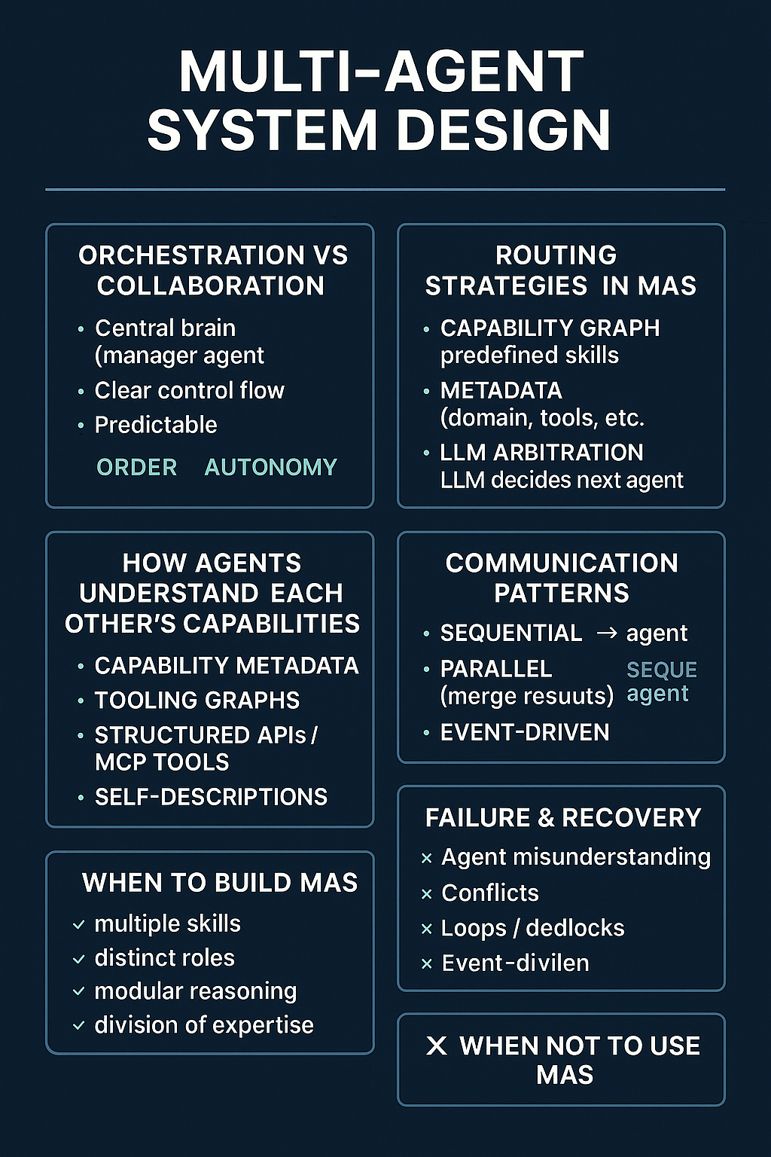

🚀 POST 5 — Memory Management in Agentic AI (The Hidden Architecture Layer)

**#AI** **#GenAI** **#Agents** **#SystemDesign** **#Memory**

In real agentic systems, memory is not a feature — it’s an architecture layer.

Good memory design improves accuracy, reduces cost, and prevents reasoning drift.

Here is the clean blueprint 👇

🔵 1️⃣ Short-Term Memory (Session Context)

Lives inside the current conversation/task:

a) Recent messages

b) Intermediate steps

c) Tool results

d) Task progress

Stored in the LLM prompt window, so it must be minimal.

Too much = confusion

Too little = repetition

🔵 2️⃣ Long-Term Memory (Persistent Knowledge)

Survives across sessions:

a) User preferences

b) Past tasks

c) Domain facts

d) Stored summaries

Common stores:

✔ Vector DB (semantic recall)

✔ JSON / NoSQL (preferences, agent profiles)

✔ SQL DB (workflow state, audit logs)

🔵 3️⃣ Episodic vs Semantic Memory

Episodic: past interactions, stored as chunks or embeddings.

Semantic: distilled facts, rules, summaries (more important for reliability).

Agents rely heavily on semantic memory for grounded reasoning.

🔵 4️⃣ Which Storage to Use?

Vector DB: unstructured text, retrieval augmentation

JSON / NoSQL: agent cards, task state, configs

Structured DB: deterministic queries, transactions

Most production systems combine all three.

🔵 5️⃣ Memory Pruning & Summarization

Memory grows fast. Control it using:

a) Sliding windows

b) LLM summaries

c) Hierarchical summaries

d) Embedding compression

e) Extracting only key facts (best practice)

Good pruning keeps reasoning stable and costs low.

🔵 6️⃣ Managing Context Window Overflow

One of the hardest design problems.

Architectural patterns:

a) Importance scoring — keep only high-value info

b) Retrieval-based context — reconstruct from vector DB

c) Role partitioning — separate instructions, examples, history, tool outputs

d) Context distillation — compress history into a single summary

e) Multi-stage reasoning — break large tasks into smaller loops

Done well, a small model can behave like a large-context model.

🔵 7️⃣ Principle: Minimal, Structured, Task-Relevant Memory

Effective memory design is about precision, not size.

✔ Relevant

✔ Structured

✔ Summarized

✔ Retrievable

✔ Purpose-driven

Memory is what makes agents reliable — not more tokens.

🔽 Up Next: Post 6 — Context Window Control Techniques

Stay tuned.

**#AI** **#GenAI** **#Agents** **#Memory** **#RAG** **#VectorDB** **#LLM** **#SystemDesign**

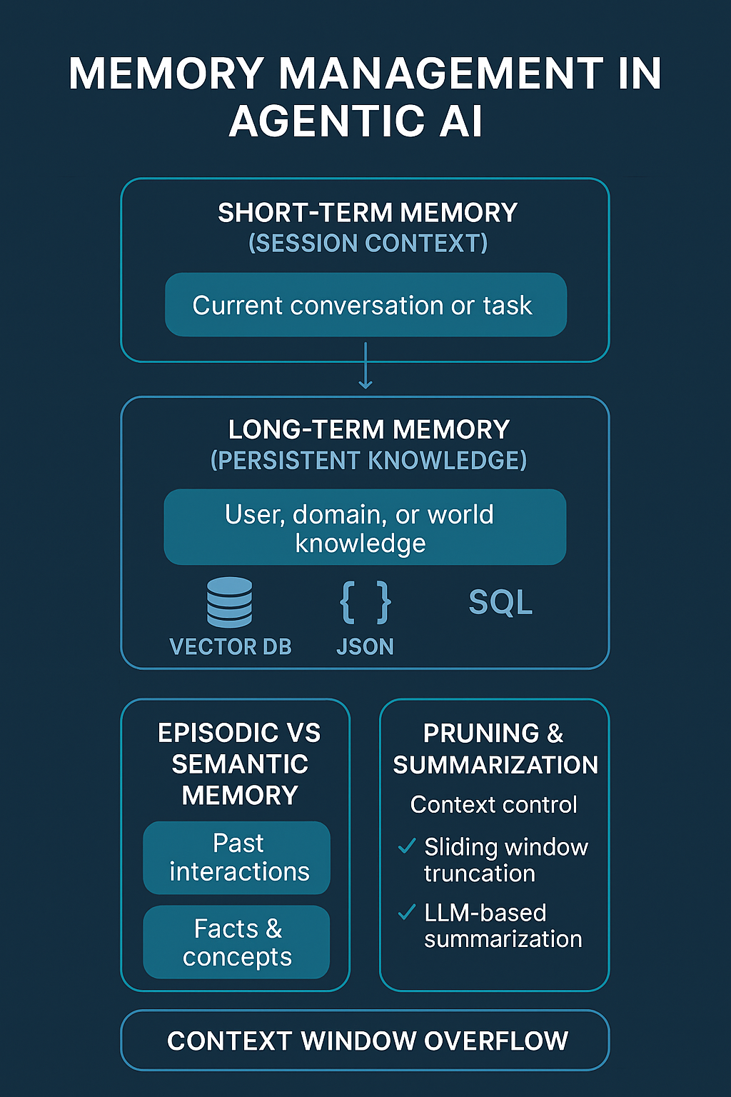

🚀 POST 6 — Context Window Control Techniques (The Real RAG Skill)

**#AI** **#GenAI** **#RAG** **#LLM** **#SystemDesign** **#Agents**

Most GenAI failures are not model failures.

They are context failures.

LLMs don’t struggle because they lack intelligence —

they struggle because we give them too much, too little, or the wrong context.

Here’s how production-grade AI systems control the context window 👇

🔵 1️⃣ Chunking Strategies (Foundation of RAG)

Chunking decides how knowledge is sliced before retrieval.

Common approaches:

a) Fixed-size chunks — simple, but noisy

b) Semantic chunking — split by meaning (better grounding)

c) Structure-aware chunking — headers, sections, tables

Bad chunking = irrelevant retrieval

Good chunking = precise reasoning

🔵 2️⃣ Query Rewriting (Ask Better Questions to Retrieve Better Context)

User queries are often vague.

Before retrieval, systems rewrite queries to:

a) Add missing intent

b) Expand key entities

c) Normalize terminology

This step alone can improve retrieval quality significantly.

🔵 3️⃣ Oracle Summarization (Compress Before Injecting)

Instead of pushing raw documents into the prompt:

✔ Summarize long content

✔ Extract task-relevant facts

✔ Reduce noise before reasoning

This creates a high-signal context, not a long one.

🔵 4️⃣ Context Distillation (Summaries of Summaries)

For long-running tasks or conversations:

a) Distill multiple turns into a single state

b) Replace history with a compact semantic summary

c) Re-embed distilled context

This keeps reasoning stable without growing the prompt.

🔵 5️⃣ Hierarchical Retrieval (Retrieve in Layers)

Instead of retrieving everything at once:

1️⃣ Retrieve coarse summaries

2️⃣ Narrow down to relevant sections

3️⃣ Pull fine-grained details only if needed

This mirrors how humans research — zoom out, then zoom in.

🔵 6️⃣ Multi-Pass Retrieval & Reasoning

Advanced agents don’t retrieve once — they iterate:

a) First pass → understand the task

b) Second pass → retrieve targeted knowledge

c) Third pass → validate or refine

Smaller context windows + multiple passes

often outperform massive single-pass prompts.

🔵 7️⃣ The Principle: Context Is a Runtime Decision

Context should be:

✔ Selected dynamically

✔ Task-driven

✔ Minimal but sufficient

✔ Reconstructed when needed

A well-designed system lets a 4k–8k context model behave like a much larger one.

🔽 Up Next: Post 7 — Scaling & Deployment Strategies for AI Systems

Stay tuned.

**#AI** **#GenAI** **#RAG** **#ContextWindow** **#LLM** **#Agents** **#SystemDesign**

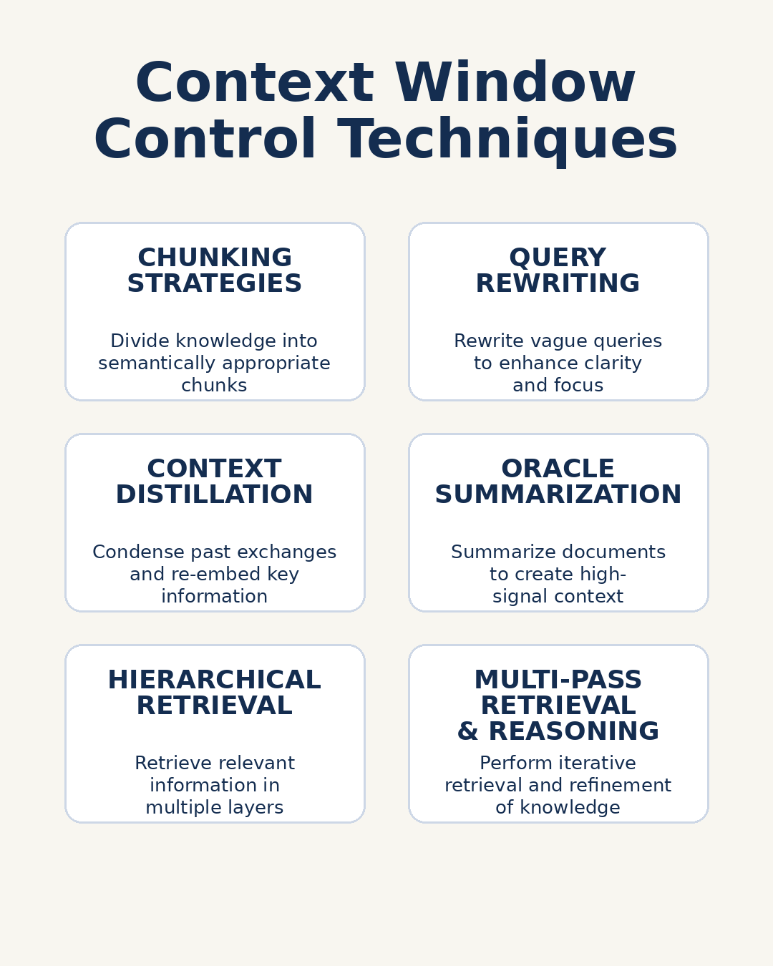

🚀 POST 7 — Scaling & Deployment Strategies for AI Systems

**#AI** **#GenAI** **#SystemDesign** **#LLM** **#Agents**

Once an AI system works correctly, the real challenge begins:

How do you run it reliably, efficiently, and at scale?

Scaling AI systems is very different from scaling traditional microservices.

Here’s the architect-level blueprint 👇

🔵 1️⃣ Compute Choices: CPU vs GPU vs TPU

Different workloads need different compute:

a) CPU → lightweight inference, embeddings, low-QPS agents

b) GPU → high-throughput LLM inference, parallel requests

c) TPU → large-scale, cost-efficient training or inference (cloud-native)

Wrong compute choice = wasted cost or poor latency.

🔵 2️⃣ Horizontal Scaling of LLM Inference

LLMs don’t scale like stateless services.

Common patterns:

a) Replica-based scaling (multiple model instances)

b) Request batching (group prompts together)

c) Async / queue-based execution

d) Model sharding for large models

Inference scalability must consider tokens/sec, not just QPS.

🔵 3️⃣ Throughput Optimization Techniques

Production systems rely on:

✔ Batching — improve GPU utilization

✔ Sharding — split models across devices

✔ Speculative decoding — reduce generation latency

✔ Streaming responses — improve perceived speed

These techniques matter more than raw model size.

🔵 4️⃣ Edge vs Cloud vs On-Prem vs Hybrid Deployment

Deployment location shapes system behavior:

a) Edge → ultra-low latency, limited capacity

b) Cloud → elastic scale, managed infra

c) On-Prem → data control, predictable cost

d) Hybrid → balance latency, cost, and compliance

Most enterprises land on hybrid architectures.

🔵 5️⃣ Reliability, Resilience & Failover

AI systems must expect failure:

a) Model timeouts

b) Tool/API failures

c) Partial agent breakdowns

Production patterns include:

✔ Model fallback chains

✔ Timeout-based retries

✔ Circuit breakers

✔ Graceful degradation (partial answers)

🔵 6️⃣ Observability & Cost Control

You can’t scale what you can’t observe.

Key signals to monitor:

a) Token usage per request

b) Latency per stage (RAG, tools, generation)

c) Error rates

d) Cost per workflow

Observability turns AI from a demo into a platform.

🔵 7️⃣ Principle: Scale the System, Not Just the Model

Most bottlenecks come from:

a) Retrieval latency

b) Tool execution

c) Context construction

d) Poor batching

Great scalability comes from system design, not just faster GPUs.

🔽 Up Next: Post 8 — Local LLMs vs Cloud LLMs vs NIM vs On-Prem vs LangGraph Cloud

Stay tuned.

**#AI** **#GenAI** **#LLM** **#SystemDesign** **#Scaling** **#Agents** **#MLOps**

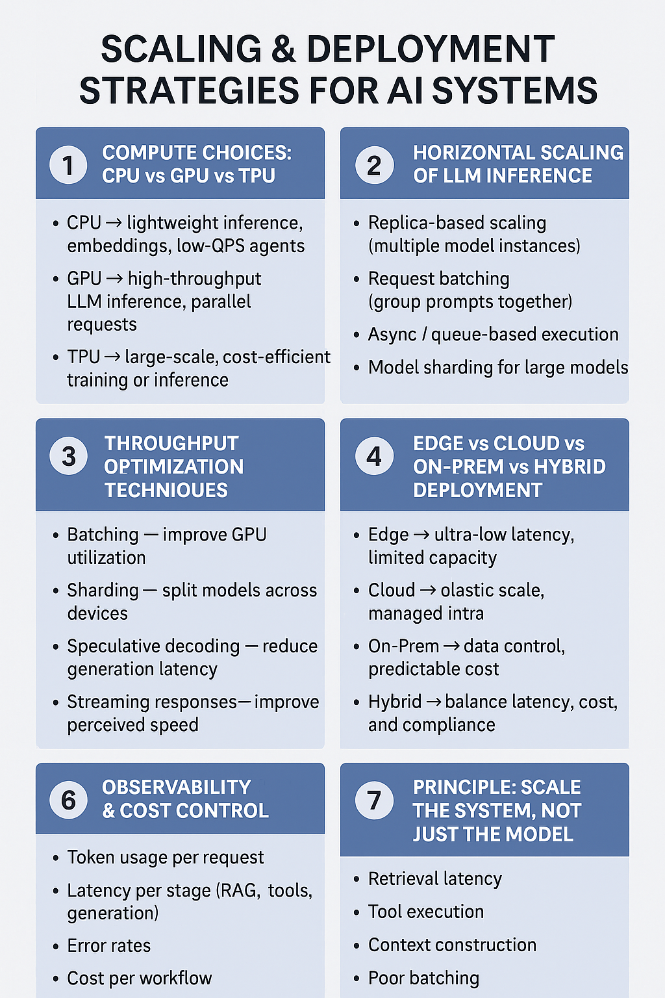

🚀 POST 8 — Local LLMs vs Cloud LLMs vs NIM vs On-Prem vs LangGraph Cloud

**#AI** **#GenAI** **#LLM** **#SystemDesign** **#Architecture**

One of the most common questions I get is:

“Where should we run our LLMs?”

There is no single “best” option.

The right choice depends on latency, security, cost, control, and enterprise constraints.

Here’s a clear, architect-level comparison 👇

🔵 1️⃣ Local LLMs (Laptop / Workstation / Small Server)

Best for: experimentation, learning, local RAG, prototypes

a) Latency: very low (local calls)

b) Security: data never leaves the machine

c) Cost: minimal infra cost, no token billing

d) Customization: high (models, prompts, embeddings)

e) Limitations: limited scale, hardware constraints

👉 Ideal for developers, POCs, and local-first workflows.

🔵 2️⃣ Cloud LLM APIs (OpenAI, Anthropic, etc.)

Best for: rapid product development and global scale

a) Latency: moderate, network-dependent

b) Security: depends on vendor & data policies

c) Cost: usage-based, can grow quickly

d) Customization: limited to prompts/fine-tuning

e) Strength: reliability and managed scale

👉 Best when speed-to-market matters more than control.

🔵 3️⃣ NVIDIA NIM (Inference Microservices)

Best for: enterprise-grade, GPU-optimized inference

a) Latency: very low with GPU acceleration

b) Security: deployable inside VPC/on-prem

c) Cost: predictable GPU-based pricing

d) Customization: strong (model choice, performance tuning)

e) Strength: performance + enterprise deployment patterns

👉 Ideal for regulated and performance-critical workloads.

🔵 4️⃣ On-Prem / Private VPC LLMs

Best for: regulated industries and strict data control

a) Latency: low and predictable

b) Security: full data ownership

c) Cost: high upfront, stable long-term

d) Customization: complete control

e) Trade-off: infra and ops complexity

👉 Common in healthcare, finance, and government.

🔵 5️⃣ LangGraph Cloud / Managed Agent Platforms

Best for: orchestration-heavy, agent-centric systems

a) Latency: moderate

b) Security: platform-dependent

c) Cost: platform + compute

d) Customization: high at workflow level

e) Strength: agent orchestration, state, memory

👉 Best when agent coordination matters more than raw inference.

🔵 6️⃣ Enterprise Trade-Offs (The Real Decision Matrix)

See the visual below for a side-by-side comparison across latency, security, cost, scale, and ops complexity.

🔵 7️⃣ Principle: Start Simple, Evolve Deliberately

Many systems evolve like this:

Local LLM → Cloud LLM → Hybrid → NIM / On-Prem → Agent Platforms

Architecture should grow with requirements, not start at maximum complexity.

🔽 Up Next: Post 9 — Availability & Consistency in AI Agent Systems

Stay tuned.

**#AI** **#GenAI** **#LLM** **#Architecture** **#Agents** **#SystemDesign** **#EnterpriseAI**

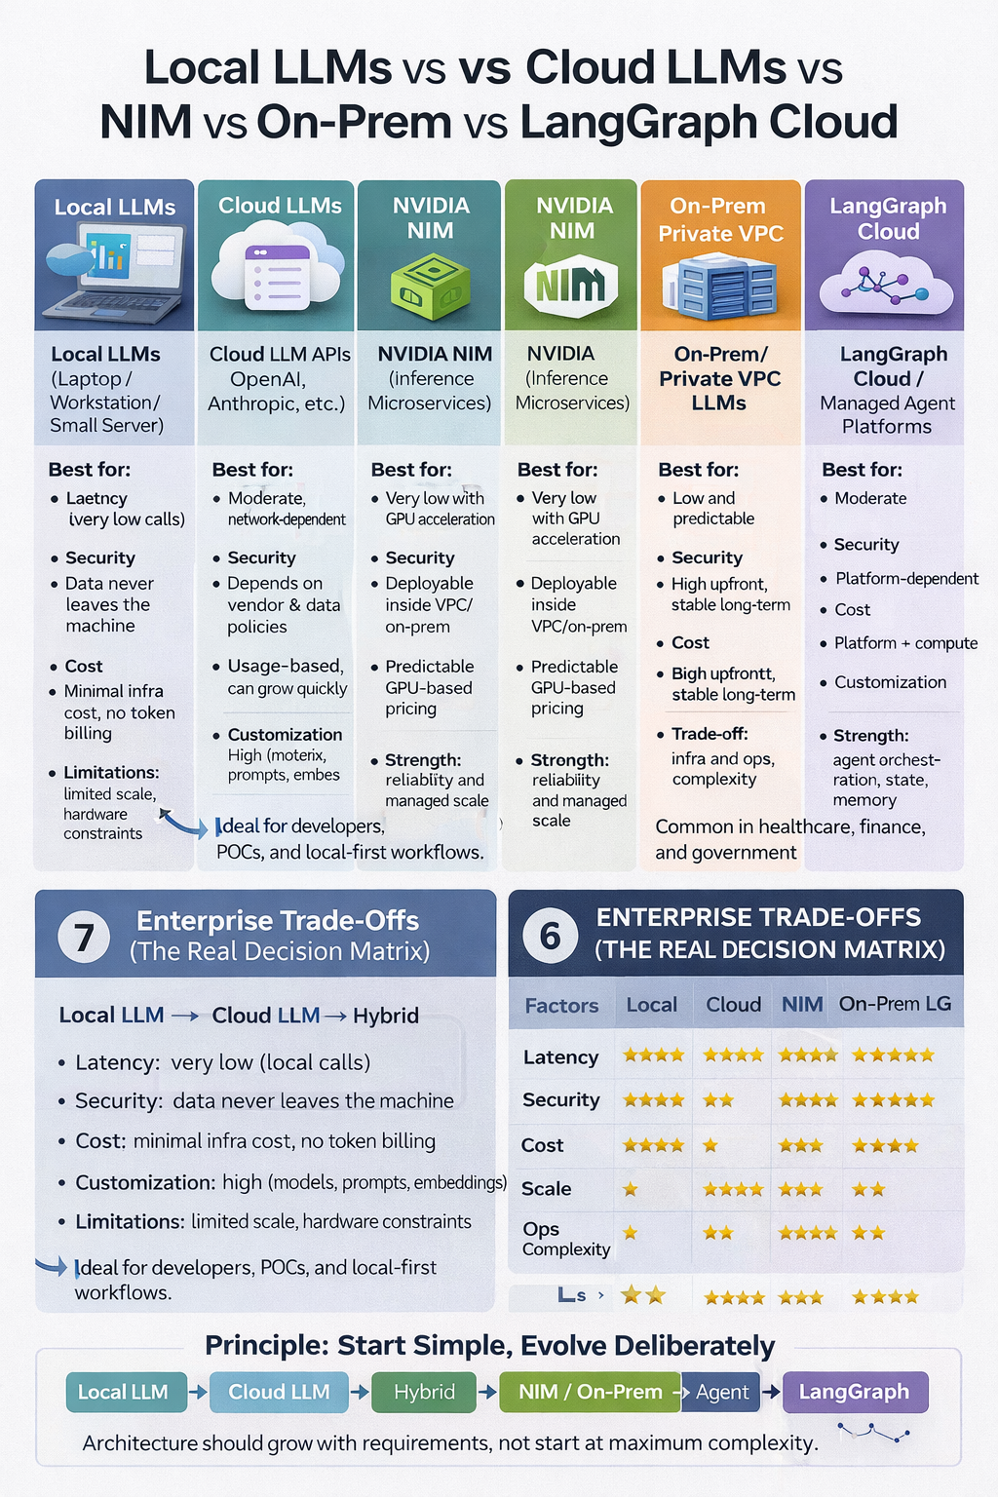

🚀 POST 9 — Availability & Consistency in AI Agent Systems

**#AI** **#GenAI** **#Agents** **#SystemDesign** **#Reliability** **#EnterpriseAI**

As AI systems move from demos to production, the real question becomes:

What happens when things go wrong?

LLMs are probabilistic.

Agents are stateful.

Tools fail.

Networks timeout.

Designing available and consistent AI systems requires a different mindset.

Here’s the practical blueprint 👇

🔵 1️⃣ AI Systems Fail Differently Than Traditional Systems

Unlike deterministic services, AI systems can fail in subtle ways:

a) Partial responses

b) Hallucinated answers

c) Tool execution failures

d) Silent degradation (slow, but “working”)

Availability isn’t just “up or down” — it’s quality of response under failure.

🔵 2️⃣ Availability Patterns for Agent Systems

Production agent systems rely on:

✔ Retries with bounds (never infinite)

✔ Timeout-based fallbacks

✔ Model fallback chains (small → large, local → cloud)

✔ Graceful degradation (partial but safe answers)

The goal is continuity, not perfection.

🔵 3️⃣ Consistency Challenges in LLM-Based Decisions

LLMs don’t guarantee consistent outputs.

Consistency issues arise from:

a) Temperature & sampling variance

b) Changing context windows

c) Non-deterministic tool calls

d) Multi-agent coordination

For critical flows, consistency must be designed, not assumed.

🔵 4️⃣ State & Context Propagation Across Agents

In multi-agent systems, inconsistency often comes from state drift:

a) Agents operate on stale context

b) Partial updates propagate

c) Conflicting decisions occur

Best practices include:

✔ Centralized state stores

✔ Versioned task context

✔ Immutable snapshots per step

✔ Clear ownership of state transitions

🔵 5️⃣ Recovery Patterns That Actually Work

When agents fail mid-task:

a) Checkpoint progress, not raw prompts

b) Replay from last stable state

c) Reconstruct context, don’t reuse broken prompts

d) Escalate to deterministic logic when needed

Recovery is a workflow problem, not an LLM problem.

🔵 6️⃣ The Trade-Off: Availability vs Consistency

Highly available AI systems may return:

a) Less detailed answers

b) Conservative responses

c) Deferred execution

Highly consistent systems may:

a) Be slower

b) Reject ambiguous requests

c) Require stricter validation

There is no free lunch — trade-offs must be explicit.

🔵 7️⃣ Principle: Design for Trust, Not Just Uptime

A system that is “up” but wrong is worse than a system that is slow but safe.

Reliable AI systems:

✔ Fail clearly

✔ Recover predictably

✔ Protect correctness

✔ Preserve user trust

Availability without consistency is noise.

Consistency without availability is friction.

🔽 Up Next: Post 10 — Rate Limits, Timeouts, Circuit Breakers & QPS Control for LLM Pipelines

Stay tuned.

**#AI** **#GenAI** **#Agents** **#Reliability** **#SystemDesign** **#LLM** **#EnterpriseAI**

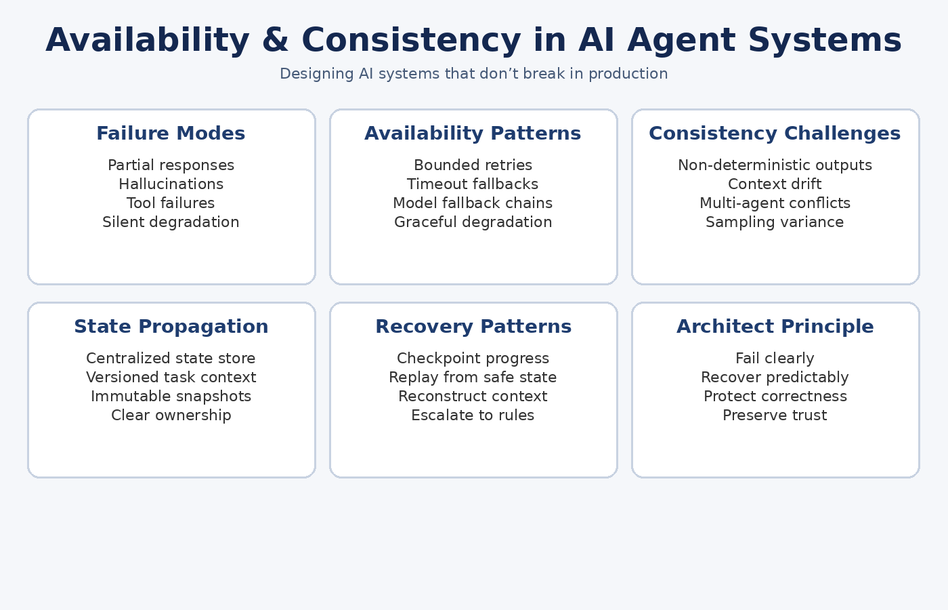

🚀 POST 10 — Rate Limits, Timeouts, Circuit Breakers & QPS Control for LLM Pipelines

**#AI** **#GenAI** **#LLM** **#SystemDesign** **#Agents** **#Reliability** **#EnterpriseAI**

As AI systems scale, failures don’t usually come from the model itself.

They come from uncontrolled traffic, unbounded execution, and runaway costs.

LLMs are expensive, stateful, and slow compared to traditional services.

They must be protected like critical infrastructure.

Here’s the production-grade blueprint 👇

🔵 1️⃣ Global vs Local Timeouts (Critical Distinction)

AI systems need timeouts at multiple layers:

a) Local timeouts → tool calls, API calls, RAG queries

b) Agent-level timeouts → reasoning loops, retries

c) Global request timeouts → end-to-end SLA

A system without layered timeouts will hang silently.

🔵 2️⃣ Circuit Breaker Patterns for LLMs

LLMs fail differently than APIs.

Effective circuit breakers handle:

a) Model latency spikes

b) Repeated hallucinations

c) Tool failures cascading across agents

Patterns that work:

✔ Open / Half-open / Closed states

✔ Model fallback chains (small → large, local → cloud)

✔ Temporary degradation instead of hard failure

Circuit breakers protect users, budgets, and downstream systems.

🔵 3️⃣ Token Budget & Cost Control

In AI systems, tokens = money + latency.

Production controls include:

a) Per-request token caps

b) Per-user / per-agent budgets

c) Context size enforcement

d) Early stopping for low-confidence outputs

Unbounded tokens are a silent production killer.

🔵 4️⃣ QPS & Burst Handling for Agent Workflows

Agents don’t generate steady traffic — they spike.

Best practices:

a) Rate limiting per user / agent / workflow

b) Burst control using queues

c) Fair usage across tenants

d) Priority lanes for critical workloads

Throughput should be measured in tokens/sec, not just requests/sec.

🔵 5️⃣ Backpressure in Agentic Systems

When one component slows down, the entire system can collapse.

Backpressure strategies:

✔ Queue depth limits

✔ Load shedding

✔ Partial execution or deferred tasks

✔ Fallback to deterministic logic

Backpressure is how systems fail safely instead of catastrophically.

🔵 6️⃣ LLM Throughput Engineering

Performance tuning isn’t just about faster models.

Key levers:

a) Request batching

b) Streaming responses

c) Speculative decoding

d) Parallel tool execution

Well-designed systems optimize end-to-end workflow latency, not raw inference speed.

🔵 7️⃣ Principle: Protect the System From the Model

LLMs are powerful — but they must be constrained.

Reliable AI systems:

✔ Bound execution

✔ Control traffic

✔ Enforce budgets

✔ Fail fast and visibly

Guardrails are not optional. They are architecture.

🔽 Up Next: Post 11 — Security for MCP, Agents, RAG & Multi-Agent Systems

Stay tuned.

**#AI** **#GenAI** **#LLM** **#SystemDesign** **#Agents** **#Reliability** **#MLOps** **#EnterpriseAI**

